

# About This Guide

This guide covers the installation, configuration, and deployment of SkeleCode created by ACIT 2911 Group 12 – SkeleCoders.

This guide is intended for the person(s) responsible for the installation and deployment of this product. The aforementioned person(s) should be familiar with installing Windows software, unzipping files, running command line arguments, accessing Github, and running git commands.

# Additional Support Information

For additional support regarding the installation, configuration, and deployment of SkeleCode; please contact ACIT 2911 Group 12 – SkeleCoders through BCIT: <https://www.bcit.ca/>

**User Documentation**

User documentation and instructions on how to operate SkeleCode can be found on the GitHub page for SkeleCode: <https://github.com/MeltedIceKing/Agile-Project#readme>. This will serve as a starting point for users to understand how to begin using SkeleCode’s features and walk the user through the program’s functionality.

# Disclaimer

This documentation is intended for BCIT course ACIT 2911: Agile Development Project use only and ACIT 2911 Group 12 – SkeleCoders is not responsible for any damages directly or indirectly inflicted by the installation or usage of SkeleCode.

# Table of Contents

**Section 1 - Preparing for Installation 1**

Section 1.1 - System Requirements **1**

Section 1.2 - Prerequisite Software **1**

**Section 2- Deployment Instructions 1**

Section 2.1 - Downloading SkeleCode from GitHub **1**

Section 2.2 - Initializing SkeleCode Server Installation **1**

Section 2.2.1 - Install Node JS **2**

Section 2.2.2 - Initialize SkeleCode Server **2**

**Section 3 - Verifying Installation 2**

**Section 4 - Configuring Installation 2**

Section 4.1 - Verify Latest Version Installation **2**

**Next Steps** **3**

# Section 1 – Preparing for Installation

## Section 1.1 System Requirements

* Windows 10/Mac OSX 10.10 or later
* 4GB RAM
* 10GB Free Disk Space

## Section 1.2 Prerequisite Software

SkeleCode requires the following prerequisite software to be installed:

* Node JS

# Section 2 – Deployment Instructions

## Section 2.1 Downloading SkeleCode from GitHub

You will need to download the SkeleCode source code from SkeleCode’s GitHub repository and unzip the files to your server or designated computer.

1. Access the GitHub repository for SkeleCode: <https://github.com/MeltedIceKing/Agile-Project.git>
2. Click on the  button to access the dropdown menu.
3. Click Download ZIP.
4. Unzip the file to your chosen destination.

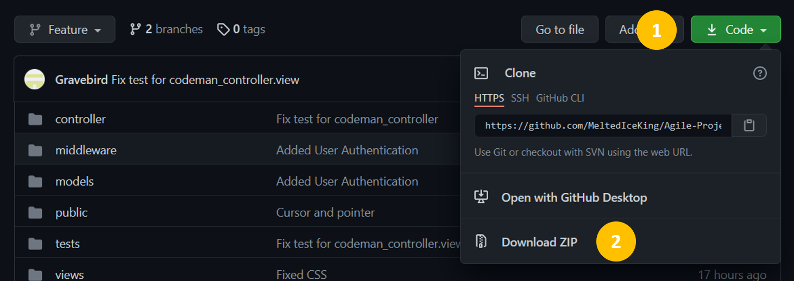

## Section 2.2 - Initializing SkeleCode Server Installation

You will need to install NodeJS to your computer/server in order to run SkeleCode.

### **Section 2.2.1 Install Node JS**

1. Visit: <https://nodejs.org/en/>
2. Download the latest version of Node JS
3. Run the executable installation file

### **Section 2.2.2 Initialize SkeleCode Server**

1. Open Command Prompt (Terminal for MacOSX).
2. Navigate to the SkeleCode folder in your command line interpreter.
3. Run the command “npm install” in the SkeleCode folder.
4. Finish installing the server requirements via the npm Javascript package manager.

# Section 3 – Verifying Installation

To verify your SkeleCode installation, you can start up SkeleCode via the Node JS server and test the functionality to ensure the program works according to user documentation.

1. Open Command Prompt (Terminal for MacOSX).
2. Navigate to the SkeleCode folder in your command line interpreter.
3. Run the command “npm start” in the SkeleCode folder.
4. Wait for the server to boot up. When the server is running, the command line interpreter will display: “Server running. Visit localhost:3001 in your browser”.
5. Access localhost:3001 in your browser of choice.
6. Verify all functionality is working according to SkeleCode user documentation: <https://github.com/MeltedIceKing/Agile-Project#readme>

# Section 4 – Configuring Installation

## Section 4.1 - Verify Latest Version Installation

1. Open Command Prompt (Terminal for MacOSX).
2. Navigate to the root directory of SkeleCode.
3. Run the command “git pull”.
4. Command Prompt should return “Already up to date” message.

**Next Steps:**

Check out the user documentation available at: <https://github.com/MeltedIceKing/Agile-Project#readme> for further instruction on operating SkeleCode and to find additional information regarding the program.